SmartBite
Ingredient Risk Reasoning System

Engineering Report
https://github.com/joshuang550-create/26INF1103-P4-team5

26INF1103-P4-team5
Student ID | Name | Email
2603203 | Ng Qi Yuan Joshua | 2603203@sit.singaporetech.edu.sg
2602465 | Lim Hong Jie Jeff | 2602465@sit.singaporetech.edu.sg
2603198 | Lee Zhan Quan | 2603198@sit.singaporetech.edu.sg
2605746 | Faeldonea Matthieu Dane Chua | 2605746@sit.singaporetech.edu.sg
2605804 | Keagan Foo Kai’en | 2605804@sit.singaporetech.edu.sg

Submitted on 16 November 2026

UML Class Diagram
Placeholder

Data Flow Diagram
Placeholder

OOP Concepts

Classes and Objects
This can be best seen in main and engine.
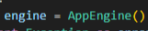 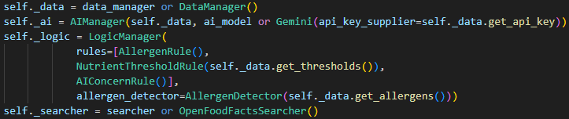
Each class has a purpose like controller, manager, entity, rule, outcome. One AppEngine instance creates and wires the other objects, and they are used on every login and food check.

Encapsulation
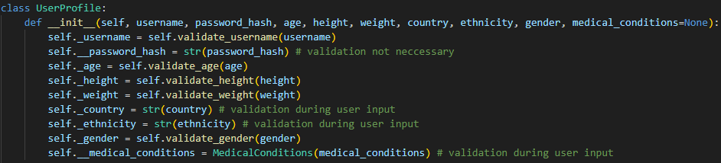
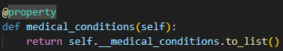 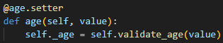
The three access levels are used deliberately. Public API, _protected helpers and fields, __private secrets and parts. For example, the password hash can’t be read from outside, username has no setter, and age can only change through validation. Medical conditions are returned as a copy so editing it will not change the profile, unless through the dedicated methods.

Abstract Classes
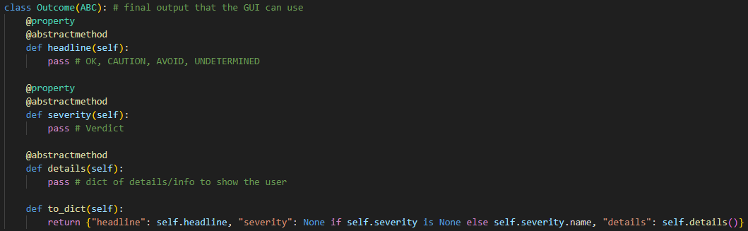
Outcome cannot be instantiated has three abstract methods headline, severity, and details. It also has a shared concrete method to_dict.

Inheritance
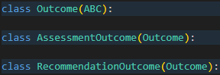 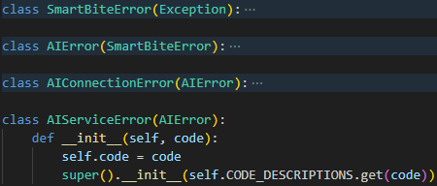
The Outcome subclasses specialise the base class by implementing its abstract methods and inherit to_dict. For errors, each subclass only sets its own title and description while inheriting the constructor. AIServiceError extends it with super().__init__.

Interfaces
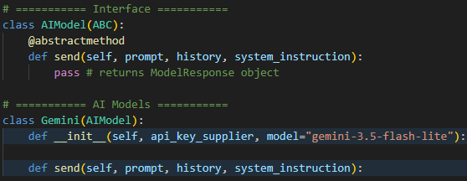
A clear example of an interface can be seen in AIModel. When an AI provider’s model is created, it needs to have a send method. The AppEngine is able to accept any other AIModel.
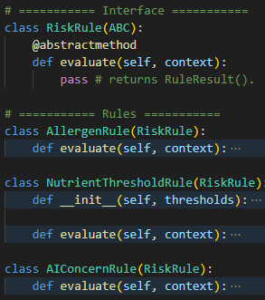
RiskRule is also an interface with an evaluate abstract method. Any rules that the LogicManager wants to apply can be created here and passed over.

Association
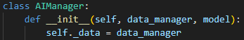
AIManager and DataManager collaborate with each other. AIManager uses DataManager for the chat history but does not create or destroy it.
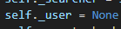 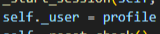 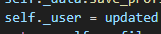
AppEngine refers to the logged-in UserProfile for the session, but it is created by DataManager.login and persists on its own.

Aggregation
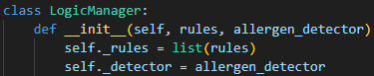 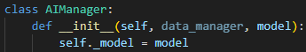
LogicManager’s verdict is made from its rules over their results and AIManager’s AI comes from its model. Both parts are built outside and are independent objects. They can be swapped with other rules or models and neither is destroyed even if the manager is.

Composition
UserProfile is the owner and creates MedicalConditions in its constructor, holds the reference and does not pass the object out. MedicalConditions only exists inside a UserProfile and is saved and loaded with it.
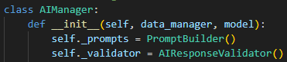 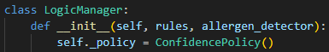
This can also be seen in AIManager and LogicManager.

Polymorphism
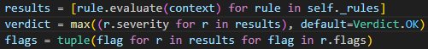
LogicManager runs three different rules without any isinstance checks.
AIManager calls send without knowing which model it has.

SOLID Principles
In this app, each class has one job. The places where the app can grow (rules, validators, tracked nutrients, AI models) are lists, tables or subclasses so behaviour is added rather than edited. Every implementation follows its interface so managers never have to check types. Here are some brief examples.

Single Responsibility Principle
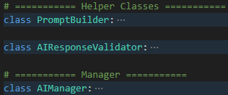 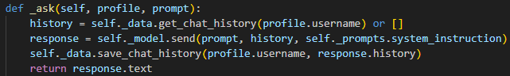
In the AI layer of the app, PromptBuilder is in charge of the wording, AIResponseValidator for validating the AI’s response, AIModel’s models deal with the actual calls, while AIManager only coordinates them.
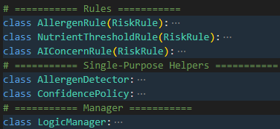
In the Logic layer, allergen detecting, policy decisions and risk rules are all separate classes, each running a part of the business logic. LogicManager combines them.

Open-Closed Principle
To add a new rule for the LogicManager, write a RiskRule subclass and add the entry to the list in the engine. LogicManager is not edited.
To track a new nutrient in thresholds.json, add the nutrient name into NUTRIENT_KEYS and ensure it is in thresholds.json. The RESPONSE_SCHEMA, EXPECTED_KEYS, validation and prompts will all follow without any edits.

Liskov Substitution Principle
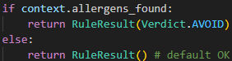 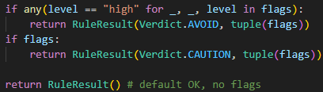 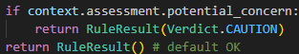
Every RiskRule returns the same type with .severity and .flags so LogicManager treats them identically.
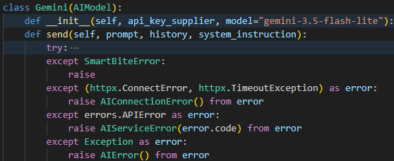 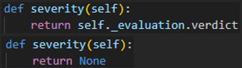 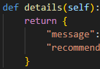 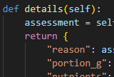
The AI models keep AIModel.send’s signature and return type. It only raises app errors as well so AIManager._ask works with any AI model.
Both Outcome subclasses return a Verdict or None for severity and a dict for details so to_dict works for either.

Dependency Inversion Principle
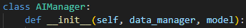
Both AIManager and AppEngine depend on the AIModel abstraction and take their collaborators from outside.

Exception-Handling Matrix
API Failures
Malformed AI Response
Corrupt/Missing Data File
Invalid User Input

New Meaningful Feature
Placeholder

New Advanced Feature
Placeholder

Continuous Integration

Automated Test Suite
Placeholder

